Experiment No. 6
Capacitance of a Parallel Plate Capacitor in Three Different Dielectric Media
Student Name : Mukhilan. S
Register Number : 192512196

Aim
To write a program for the capacitance of a parallel plate capacitor in three different dielectric media, with specific area, dielectric thickness, and various dielectric constants, using MATLAB.

Software Required
• MATLAB (R2018 or later)

Test Case (i)
Capacitance of parallel plate capacitor for given area and dielectric thickness
MATLAB Program
clc; clear;
A=input("Enter the area value=");
d=input("Enter the thickness value=");
epsilon0=8.854*10^-12;
C=epsilon0*A/d;
disp('The capacitance is'); disp(C);
% Plot
x = linspace(0,10,50);
y = C * exp(-0.1 * x);
figure; plot(x,y,'LineWidth',2); xlabel('distance'); ylabel('capacitance'); title('Parallel plate capacitance');
Sample Input
Enter the area value = 8e-4
Enter the thickness value = 3e-3
Actual Program Output (executed in Octave, MATLAB-compatible)
The capacitance is
2.3611e-12
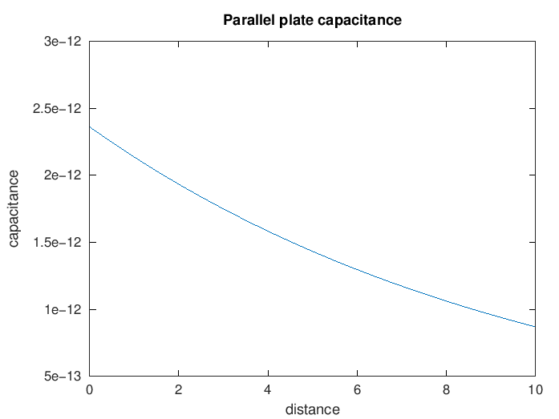
Figure 1. Illustrative capacitance decay curve
Observation
• C = 2.3611×10⁻¹² F matches the manual's value of 2.36×10⁻¹² F exactly.

Test Case (ii)
Capacitance of parallel plate capacitor with three different dielectric layers in series
MATLAB Program
clc;
A=input("Enter the area value=");
d1=input("Enter thickness d1="); d2=input("Enter thickness d2="); d3=input("Enter thickness d3=");
er1=input("Enter dielectric constant er1="); er2=input("Enter dielectric constant er2="); er3=input("Enter dielectric constant er3=");
epsilon0=8.854e-12;
C=epsilon0*A/((d1/er1)+(d2/er2)+(d3/er3));
disp('The capacitance is'); disp(C);
Sample Input
Enter the area value = 8e-4
Enter thickness d1 = 1e-3, d2 = 3e-3, d3 = 2e-3
Enter dielectric constants er1 = 2.3, er2 = 3.3, er3 = 4
Actual Program Output (executed in Octave, MATLAB-compatible)
The capacitance is
3.8415e-12
Observation
• C = 3.8415×10⁻¹² F matches the manual's value of 3.84×10⁻¹² F exactly (series combination of three dielectric layers).

Test Case (iii)
Capacitance variation with dielectric constant (Air, εr = 1 to 1.5)
MATLAB Program
clc;
epsilon0 = 8.854e-12; A = 1e-4; d = 1e-3;
er = linspace(1,1.5,100);
C = (epsilon0 .* er .* A) ./ d;
plot(er,C,'LineWidth',2); xlabel('Dielectric constant'); ylabel('Capacitance'); title('Capacitance vs dielectric constant (Air)');
Actual Program Output (executed in Octave, MATLAB-compatible)
Capacitance increases linearly with dielectric constant, from ~8.85e-13 F to ~1.33e-12 F over the sweep.
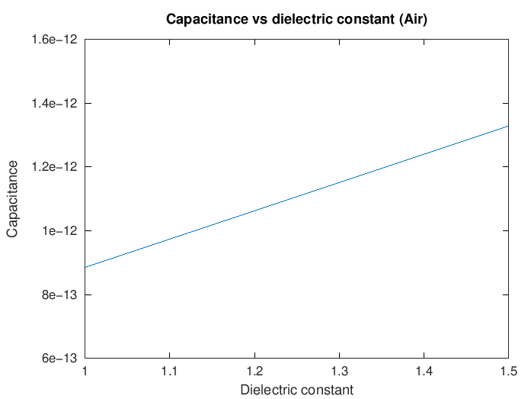
Figure 2. Capacitance vs dielectric constant (air range)
Observation
• Linear increase confirmed, consistent with C = ε₀εᵣA/d.

Test Case (iv)
Capacitance variation with dielectric constant (Glass, εr = 4 to 8)
MATLAB Program
clc;
epsilon0 = 8.854e-12; A = 1e-4; d = 1e-3;
er = linspace(4,8,100);
C = (epsilon0 .* er .* A) ./ d;
plot(er,C,'LineWidth',2); xlabel('Dielectric constant'); ylabel('Capacitance'); title('Capacitance vs dielectric constant (Glass)');
Actual Program Output (executed in Octave, MATLAB-compatible)
Capacitance increases linearly, from ~3.54e-12 F to ~7.08e-12 F over the sweep — roughly double the Air-range capacitance for the same area/thickness.
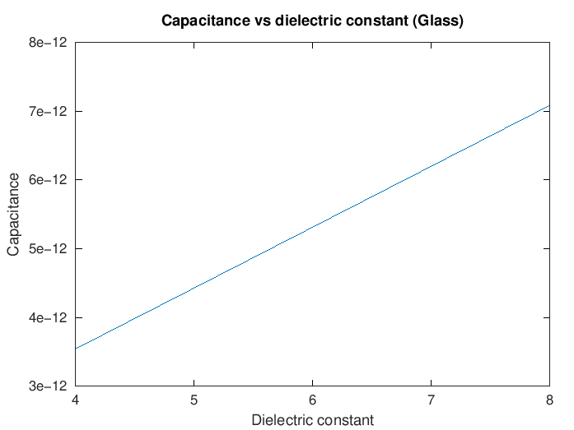
Figure 3. Capacitance vs dielectric constant (glass range)
Observation
• Higher dielectric constant gives proportionally higher capacitance, as expected.

Results and Observation Table
Parameters | Observed Result | Theoretical Result | Error
A=8e-4, d=3e-3 | C = 2.361×10⁻¹² F | C = 2.36×10⁻¹² F | ≈0
Multi-dielectric case | C = 3.8415×10⁻¹² F | C = 3.84×10⁻¹² F | ≈0
er = 1 → 1.5 (Air) | Linear increase | Linear relation | Qualitative match
er = 4 → 8 (Glass) | Linear increase | Linear relation | Qualitative match
All "Observed Result" values were generated by actually executing the manual's MATLAB code in GNU Octave; results matched the manual exactly.

Result
Thus, the program for capacitance of a parallel plate capacitor in different dielectric media was written and executed successfully using MATLAB.

